Feedback for changes to the prelim drawings: (26 November)

Ground floor :
- Remove skylight from main bathroom-Actioned
- Internals for Master Ensuite, Master WIR are to be refreshed cosmetically
- BIR added for bed 3- Bed 3 BIR move to wall backing onto stairs
- Note for Matt- Windows of existing to be upgraded to standard needed
- Highlight Window to be added in stairs location on north wall- This still needs to be updated as discussed last time if possible
- Question- Is the step out from dining to alfresco one level or is it step down?( we prefer level if possible)-actioned
- 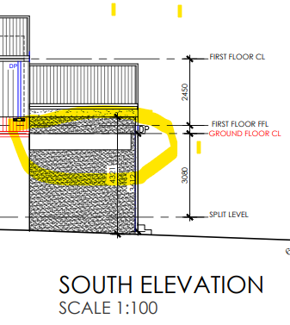
- Is the highlighted -alfresco south wall a cut out- if so can we enclose completely please-Actioned
Back façade windows:
- D2 – shrink to 2700mm from 2830mm ( stacker doors like Allie’s)- Actioned
- W3- to extend further down as per discussion today to make up the Gap-Actioned
- Highlight window as discussed on the north elevation and like model concept – can this be openable given we don’t have many openable windows in the downstairs area- To be updated
- W1- Should we consider another window – there’s likely to be a couch running along that window – what are your thoughts on this current window- Actioned
First floor
- Cathedral ceilings throughout- Actioned
- W5 – to be moved 1700mm from floor-Actioned
- W7(now w9) – to be made more of a highlight window 600mm height and 1700 from floor-Actioned
- Include window to front façade within bed 4 walking robe- Actioned
- W6 appears twice on the plan – please confirm as bed 4 internal window doesn’t appear to be in the schedule( W4 and W8)- Actioned
- Not sure if these need to be included in drawings-Shower screens to first floor ensuite- Actioned
- Vanity to sit between shower screen and wall with equal gaps either side-Actioned

First floor internal:
- Joinery to wall overlooking void in retreat
- Internal window to wall overlooking void in retreat- full floor to ceiling
See Photo below:
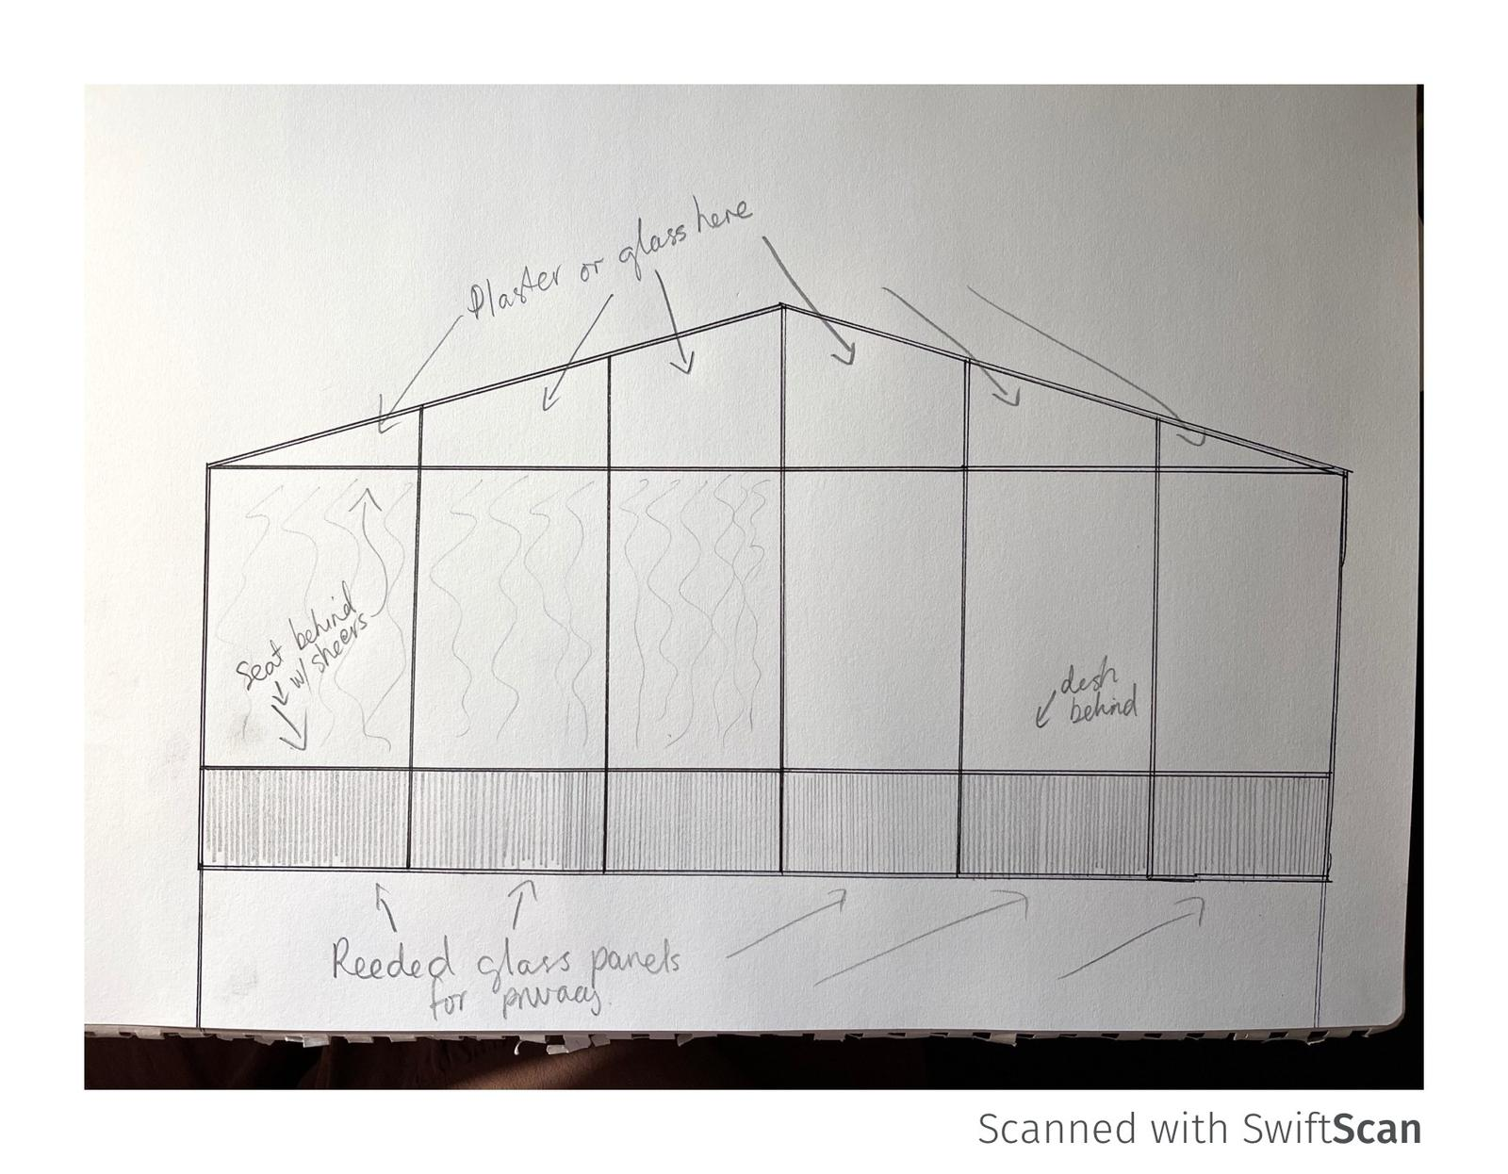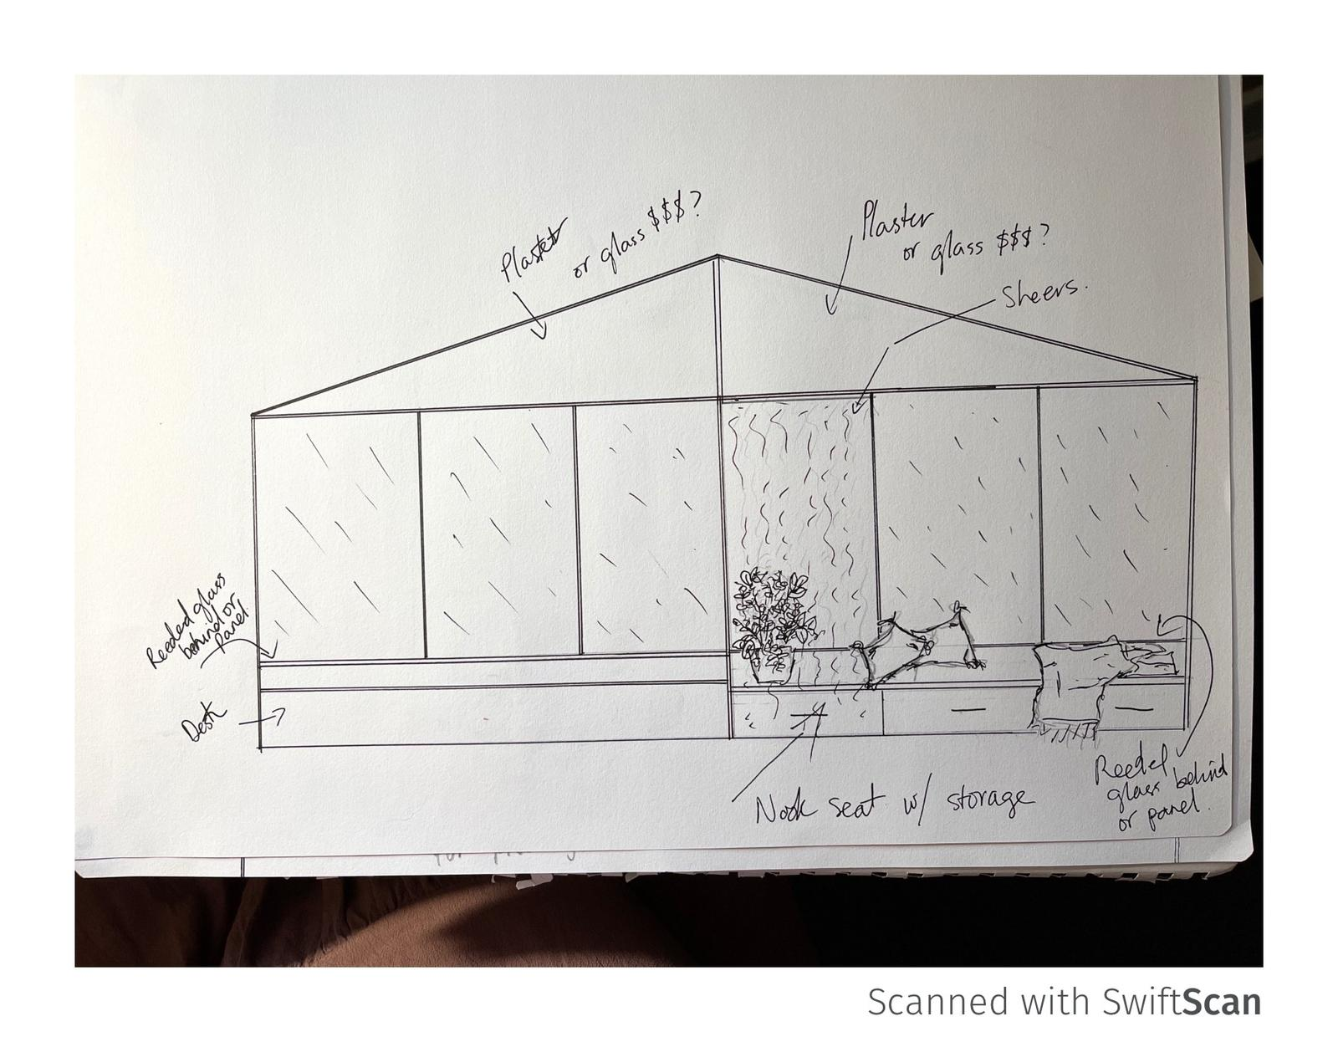
- Bed 4 window (W8) to start at bench height (think that’s 450mm and squared off (not to ceiling)- Actioned
- See reference photo below- sorry crap drawing
- 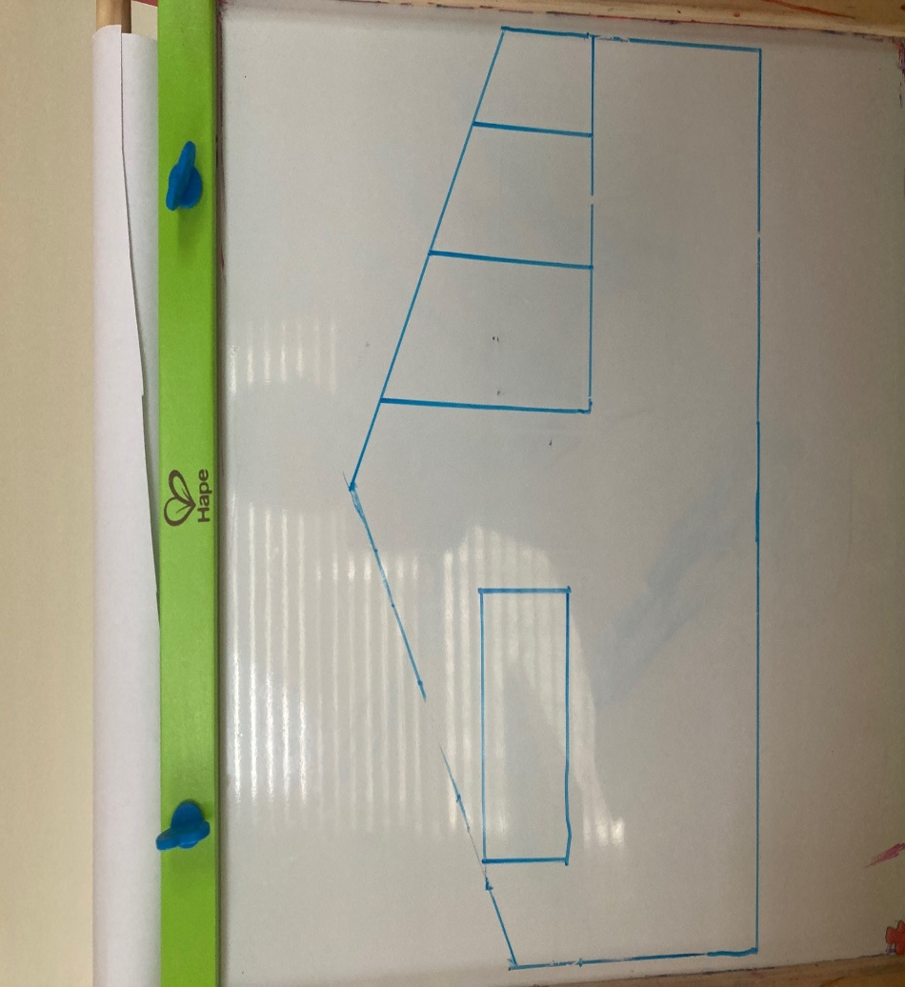
Lighting and Electrical Plan feedback- can we finalise this at a later stage
Notes for Matt to consider when budgeting
- Complete roof to be replaced if possible
- Steps /porch front door to be refreshed
- Cosmetic lift to older part of the house
- External painting of original part of the house
- Can Upstairs skylight be openable to allow for circulation in the ensuite
- Do we need to outline at this point which windows need to be openable at this stage?
- Matt – could we explore axon cladding for extension and potentially thermony cladding for the back? Whichever would keep us on budget
- Thinking if we were entertaining in the extension of the house, any thoughts on how we could potentially cut off noise down the hallway into the bedrooms( only thing we can come up is doors at step down into the extension, but don’t think that would work)
- Electrical plan feedback- we have a lighting plan appointment with Lights Lights Lights next week- we want to make sure we have some pendants etc covered

